Nabeel Ahmed
D206 Performance Assessment
10/27/2024

- Research Problem:
  - Research Question:
Which factors, between services that each customer signed up for, customer account information, and customer demographics, influence customer churn rate the most?
  - List of Variables:
-CaseOrder:
Qualitative
This keeps the order of the data
ex. 1, 2, 3, 4, 5
-Customer_id:
Qualitative
Customers ID Number
ex. K409198
-Interaction:
Qualitative
ID of the customers transaction
ex. aa90260b-4141-4a24-8e36-b04ce1f4f77b
-City:
Qualitative
City of the customer
ex. Point Baker
-State:
Qualitative
State of the customer
ex. AK
-County:
Qualitative
Country of the customer
ex. Prince of Wales-Hyder
-Zip:
Quantitative
Zipcode of the customer
ex. 99927
-Lat:
Quantitative
latitude coordinate of the customer
ex. 56.251
-Lng:
Quantitative
longitude coordinate of the customer
ex. -133.37571
-Population:
Quantitative
population within a mile radius of the customer
ex. 38
-Area:
Qualitative
Type of Area
ex. Urban
-TimeZone:
Qualitative
Time zone of customer
ex. America/Sitka
-Job:
Qualitative
Job of the customer
ex. Environmental health practitioner
-Children:
Quantitative
How many children the customer has
ex. NA, 1, 2, 3
-Age:
Quantitative
Age of the customer
ex. 68
-Education:
Qualitative
Education of customer
ex. Master's Degree
-Employment:
Qualitative
Employment status of customer
ex. Part Time
-Income:
Quantitative
Income of customer
ex. 28561.99
-Marital:
Qualitative
Marital status of customer
ex. Widowed
-Gender:
Qualitative
Gender of the customer
ex. Male, Female
-Churn:
Qualitative
If the customer has canceled the service in the last month
ex. Yes, no
-Outage_sec_perweek:
Quantitative
Average number the system is out per week
ex. 6.972566093
-Email:
Quantitative
Number of emails sent to customer in last year
ex. 10
-Contacts:
Quantitative
Number of times customer contacts customer support
ex. 0, 1, 2
-Yearly_equip_failure:
Quantitative
Yearly failure of customers equipment
ex. 0, 1, 2
-Techie:
Qualitative
Customer technical status
ex. Yes, No
-Contract:
Qualitative
Contract term of customer
ex. One year, Month-to-month
-Port_modem:
Qualitative
Whether customer has a port modem
ex. Yes, No
-Tablet:
Qualitative
Whether customer has a tablet
ex. Yes, No
-InternetService:
Qualitative
The customers internet provider
ex. Fiber Optic
-Phone:
Qualitative
Whether the customer has a phone
ex. Yes, No
-Multiple:
Qualitative
Whether customer has multiple lines
ex. Yes, No
-OnlineSecurity:
Qualitative
Whether customer has online security
ex. Yes, No
-OnlineBackup:
Qualitative
Whether the customer has online backup
ex. Yes, No
-DeviceProtection:
Qualitative
Whether the customer has device protection
ex. Yes, No
-TechSupport:
Qualitative
Whether the customer has technical support
ex. Yes, No
-StreamingTV:
Qualitative
Whether the customer has a streaming streaming TV
ex. Yes, No
-StreamingMovies:
Qualitative
Whether the customer has streaming movies
ex. Yes, No
-PaperlessBilling:
Qualitative
Whether the customer has paperless billing
ex. Yes, No
-PaymentMethod:
Qualitative
The customers payment method
ex. Credit Card (automatic), Bank Transfer(automatic)
-Tenure:
Quantitative
How long the customer has stayed with the provider in months
ex. 6.795512947
-MonthlyCharge:
Quantitative
The amount charged to the customer per month
ex. 171.4497621
-Bandwidth_GB_Year:
Quantitative
The amount of data used by the customer yearly in GB
ex. 904.5361102
-Item1: Quantitative
-Item2: Quantitative
-Item3: Quantitative
-Item4: Quantitative
-Item5: Quantitative
-Item6: Quantitative
-Item7: Quantitative
-Item8: Quantitative
All the above are survey answers to a poll they were given.
ex. 1,2,3,4,5,6,7,8
- Data-Cleaning Plan
  - Plan:
My plan to assess the quality of the data is quite simple and requires only 4 steps.
    - first step will be doing a check in the data to make sure there are no duplicates. To do this I will use the duplicates() function.
    - Next, I will check to see if there are any missing values that can be imputed for all data points. Using isnull().sum(), I can get all the columns with missing values.
    - After that I will check to see if there are any outliers that can be mitigated and corrected for all qualitative variables. I plan on using Z-score to detect the outliers. The function for that is stats.zscore()
    - Lastly, I will check to see if we can re-express any data points for categorical variables. I used the unique() function to find out if re-expression was needed.
  - Justification
I used the above strategy for assessing the data because these four steps are what I thought were the most concise and efficient ways to access this data. The data is all of customer information, such as services used by customer, customer demographic, and customer information. These two types of data here are quantitative and qualitative/categorical.
Above I stated function used to access the quality of the data.
    - For finding duplicates, I used the duplicated() function, and this function will detect if there are any duplicates. I found that this was the most efficient way to find any duplicates and remove them if needed
    - For finding missing values, I used the isnull().sum() function to identify any columns that have missing values. This was a very convenient function that easily allowed me to access the missing values for each column making the treatment very straightforward
    - For checking outliers, I used Z-score to find any values that are more than three standard deviations from the mean. I used this method because I found that using standard deviations to find outliers was most effective
    - For checking if I need to re-express any variables, I used the unique() function to check for any values that don’t match up in the categorical variables. This function helped me easily find the values for all categorical variables for me to check if re-expression is necessary
  - Program used:
The program is used for this is Python. I saw that the dataset was quite large and thought python would be more. The libraries and easy to learn nature of python gravitated to me for the use of this assignment. I found that the nature of writing the code and understanding it was most simple for me to complete the assignment.
The libraries and packages used were:
    - Pandas: this is the main library used for data analysis in python, it allows for the funcions, isnull(), fillna(), duplicated(), replace(), and many more to be used
    - Numpy: this helped with finding Z-score since it allows for function such as, mean(), median(), and mode()
    - Scipy: this was used to pull the ‘stats’ module which was used to calculate zscore
    - Matplotlib.pyplot: this library help with the visualization aspect of python. we needed this to plot any graphs that were needed
    - Seaborn: this was used to enhance the graphs that were created by the above library, which helped us better analyze and understand the graphs
    - Sklearn.decomposition: this library was needed to pull he PCA module to help us with finding PCA
- Data-Cleansing
  - Findings:
    - I found 0 duplicates in the dataset
    - I found 9 variables with missing data
      - Children: with 2495 missing values
      - Age: with 2475 missing values
      - Income: with 2490 missing values
      - Techie: with 2477 missing values
      - InternetService: with 2129 missing values
      - Phone: with 1026 missing values
      - TechSupport: with 991 missing values
      - Tenure: with 931 missing values
      - Bandwidth_GB_Year: with 1021 missing values
    - I found 16 variables with outliers
      - Lat: 151 outliers; range (17.96612, 70.64066)
      - Lng: 102 outliers; range (-171.68815, -143.078)
      - Population: 219 outliers; range (53098, 111850)
      - Outage_sec_perweek: 491 outliers; range (32.58126, 47.04928)
      - Email: 12 outliers; range (1, 23)
      - Contacts: 165 outliers; range (4, 7)
      - Yearly_equip_failure: 94 outliers; range (3, 6)
      - MonthlyCharge: 3 outliers; range (306.268, 315.8786)
      - Item1: 19 outliers; range (7, 7)
      - Item2: 13 outliers; range (7, 7)
      - Item3: 13 outliers; range (7, 8)
      - Item4: 9 outliers; range (7, 7)
      - Item5: 12 outliers; range (7, 7)
      - Item6: 13 outliers; range (7, 8)
      - Item7: 11 outliers; range (7, 7)
      - Item8: 15 outliers; range (7, 8)
    - I found 0 values that needed to be re-expressed
Please checked attached code for detection code (D206.ipynb)
  - Justification
    - Below you can see the code that I used to treat the duplicates. I used this method since it was the simplest and most straight forward way to detect any duplicates and treat them.
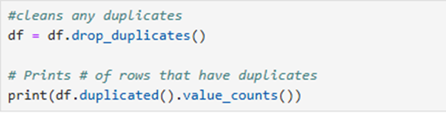
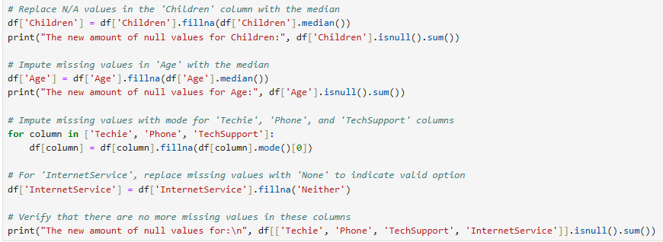
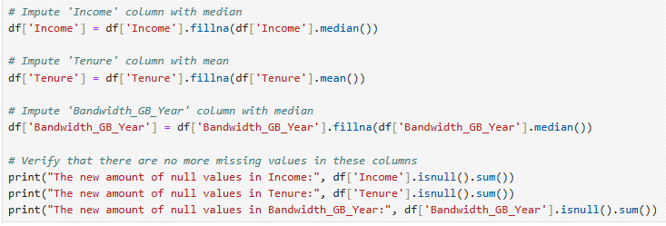
    - In the screenshots below you can see how I treated the missing values. For ‘Children’ and ‘Age’ I wanted to use the median to treat the missing values since the mean would make the values into decimals and the median and mean for both variables were very close, if not the same. For ‘Techie’, ‘Phone’, and ‘TechSupport’, I wanted to use mode since these are all categorical variables. I figured for ‘InternetService’ that there were no missing values, so I decided to just impute the ‘None’ for ‘Neither.
As for ‘Income’, ‘Tenure’, and ‘Bandwidth_GB_Year’, I decided to plot histograms for these so I could determine to either use mean or median. In the end I figured that Tenure was the only one that was symmetrical and allowed me to use mean to impute. The other two I used median to impute the missing value
    - I concluded that even though I found outliers, all these variables are expected to be spread out and be out of the three standard deviation because of the nature of the data, therefore I did not treat outliers.
    - I did not find any variables that needed to be re-expressed, below is a screenshot of the values found for categorical variables
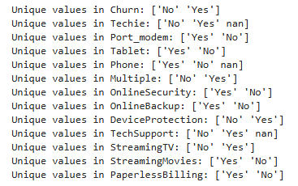
  - Outcome
In the code that was written, I made sure to confirm that the duplicates and missing data were all cleaned. After I took steps to clean the data, I printed the number of duplicates or missing data to confirm the steps were being executed as intended. Below I will insert images of the results of the confirmations.
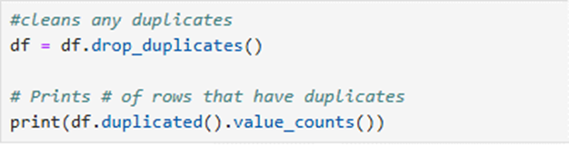
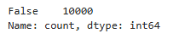
This is the result of imputing the missing data, this shows that now there are no more missing data values for these variables
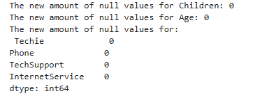
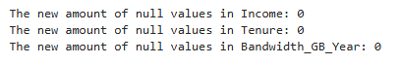
The data is clean from all duplicates and missing data values. As for the outliers and re-expressed variables, I found justification in not cleaning these values. The outliers that were found are expected to be on a large scale of difference because of the nature of the variables. Re-expression is not needed since keeping the values as yes/no gives us an easier understanding of the data.
Please checked attached code for treatment proof and outcome code (D206.ipynb)
  - Limitations
    - Duplicates
      - Detection: Using the duplicates() function checks for full duplicates and but not partial, so that could lead to some duplicates slipping through the crack since they are not exactly the same.
      - Treatment: using drop_duplicates() is a oversimplified way to get rid of duplicates which could cause for loss of legitimate data
    - Missing values
      - Detection: Using the isnull().sum() function may be quite simple to just find all null values and fix them but this method doesn’t search deeper into why the data is missing, it doesn’t search for patterns of missing data which could tell us more about the data
      - Treatment: We used imputation of mean and median for numerical values, and mode for categorical. Imputing in this style is making many assumptions and also may create outliers due to these assumptions (Keita, 2023)
    - Outliers
      - The detection method used was Z-score. Z-score checked data points based on the normal distribution of those data points, yet there’s data that may not need to be normally distributed and this method would still instantly state that those data points are outliers. I experienced this very thing when trying to treat the outliers, I found that the data points for the variables found did not need to be in the normal distribution based solely on the nature of the data.
  - Limitation Affect
Although the missing values, outliers, and duplicates were assessed and treated, the quality of the data may still be at risk for future analysts that look at the data. Just like what I talked about above, the oversimplification of the duplication to the assumptions made from imputing missing values could severely affect the processes that businesses have pertaining to churn rate. More research needs to be done before imputing is done to make sure it is not pushing us further away from answer by using assumptions.
In conclusion, this pushes us further to make sure we use complex and effective ways to assess data moving forward to ensure the integrity of the data stays true for any questions that businesses need answers to. We are looking for which variables are affecting churn rate and for this we will need high level and refined data cleaning methods to get reliable and true data.
- Code and Cleaned Data
  - https://1drv.ms/u/c/c88bd4bdf13b5718/EajzosuMTCZHqXFzrwFn84EBrctu44DpgB4t-qxVfPPAXQ?e=xxNVhD
  - https://1drv.ms/x/c/c88bd4bdf13b5718/EavlZNfz8fFOuxiBnA7mBRYBBjWFGIFaoLujmExGewvwbw?e=1ihpb6
- PCA
  - These are the variables I used for PCA
Lat, Lng, Income, Outage_sec_perweek, Tenure, MonthlyCharge, Bandwidth_GB_Year
Below is the PCA loading Matrix
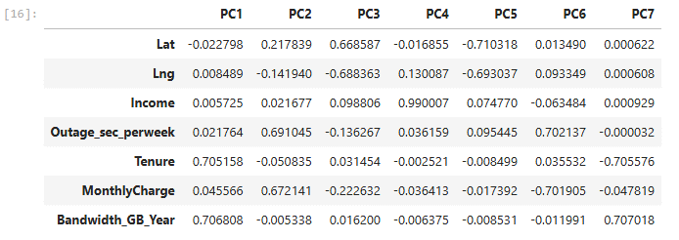
  - Kaiser Criterion states that components with an eigenvalue greater than or equal to 1 are retained since they are greater contributors of information. In the plot below we can see the red line signifying the eigenvalue of 1. We see PC1, PC2, and PC3 are all greater than 1 suggesting that they provide sufficient information to be retained, and the rest can be dropped. The elbow method can also be used, as the plot shows the rest of the components are dropping off less than 1 eigenvalue
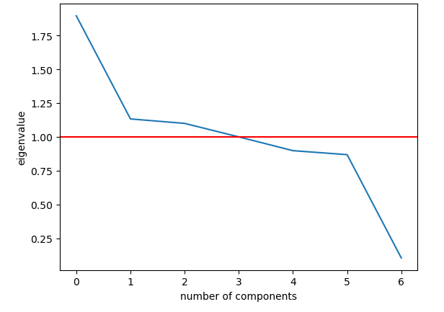
  - PCA is very beneficial in filtering out the variables that contribute less and retain the variables that have more contribution. This helps organizations simplify and easily analyze the data that matters most. This simplification can cause less accuracy but traded off for easy analysis and quicker use of machine learning (Jaadi, 2024). By making the data simpler, it would be easier to capture patterns in the data that could help push for answers to business needs and questions. Once analysis starts the key variables that are retained will be used to create more impactful models that can answer questions such as the one stated above about which factors contribute to churn rate.
In conclusion, the simplicity yet impactful nature of using PCA is advantageous to businesses in many aspects, from easy analysis to eventually even saving the business time and money. These factors of using PCA are reasons that businesses would benefit from it.
- Ponapto Video: https://wgu.hosted.panopto.com/Panopto/Pages/Viewer.aspx?id=535efb41-ed20-4061-8455-b217007e9cee
- Code Citations:
Bobbitt, Z. (2021, June 7). How to calculate Z-scores in Python. Statology. https://www.statology.org/z-score-python/

Kumar, A. (2023, December 18). Python - replace missing values with mean, median & mode. Analytics Yogi. https://vitalflux.com/pandas-impute-missing-values-mean-median-mode/
- In-text Citations:
Jaadi, Z. (2024). Principal Component Analysis (PCA) explained. Built In. https://builtin.com/data-science/step-step-explanation-principal-component-analysis
Keita, Z. (2023, January 31). Top techniques to handle missing values every data scientist should know. DataCamp. https://www.datacamp.com/tutorial/techniques-to-handle-missing-data-values

